EXPERIMENT 11
PERFORM A CROSS-SITE REQUEST FORGERY (CSRF) ATTACK
Name: VIJAY VARSITH I
Register Number: 2419101125

Aim
To study and demonstrate a Cross-Site Request Forgery (CSRF) scenario in the intentionally vulnerable DVWA application by inspecting the password-change request at Low security using Burp Suite.

Tools Required
- Kali Linux (WSL)
- Damn Vulnerable Web Application (DVWA)
- Burp Suite Community Edition
- Web browser
- Text editor and local HTTP server (for the optional proof-of-concept page)

Theory
Cross-Site Request Forgery (CSRF) is a web security weakness in which a browser that is already authenticated to a website may be induced to send an unwanted request. If the application does not adequately verify that the request was intentionally initiated by the user, a state-changing action may be performed. Common defenses include unpredictable anti-CSRF tokens, suitable SameSite cookie settings, and re-authentication for sensitive actions.

Procedure
- Start the DVWA service in Kali and open http://127.0.0.1:42001 in the browser.
- Log in to DVWA and open DVWA Security. Set the security level to Low and save the setting.
- Select Vulnerabilities → CSRF to display the password-change form.
- Open Burp Suite and use Proxy → HTTP history to locate the request sent by the CSRF page.
- Inspect the request parameters. The captured request contains password_new, password_conf, and Change=Change. The displayed request does not contain a user_token parameter.
- Inspect the response. The supplied capture shows HTTP/1.1 200 OK and the DVWA CSRF page HTML. This response confirms that the page was returned, but by itself does not prove that the password was changed.
- If required by the lab instructor, perform a controlled proof-of-concept only against this local DVWA instance, then verify the outcome using DVWA's Test Credentials control. Do not test against any real or third-party website.

Screenshots / Observations
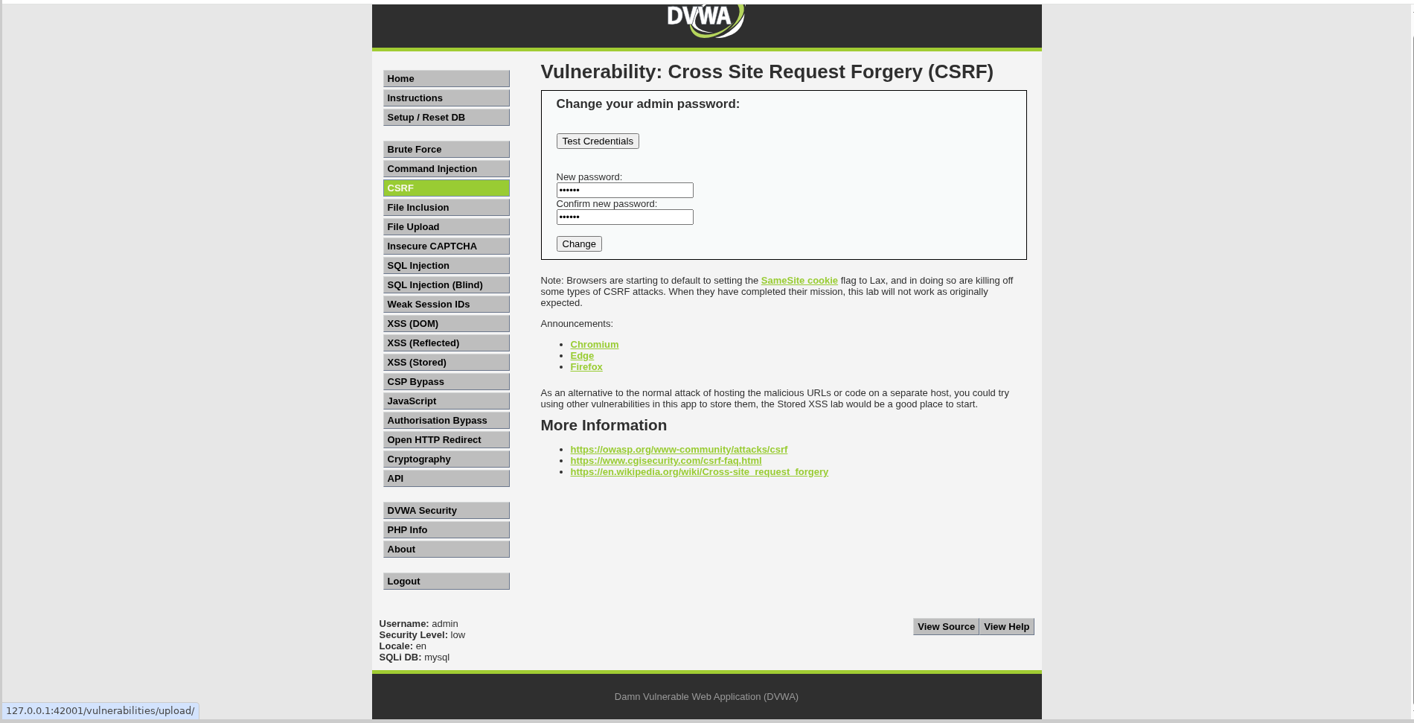
Figure 1: DVWA CSRF password-change page at Low security.
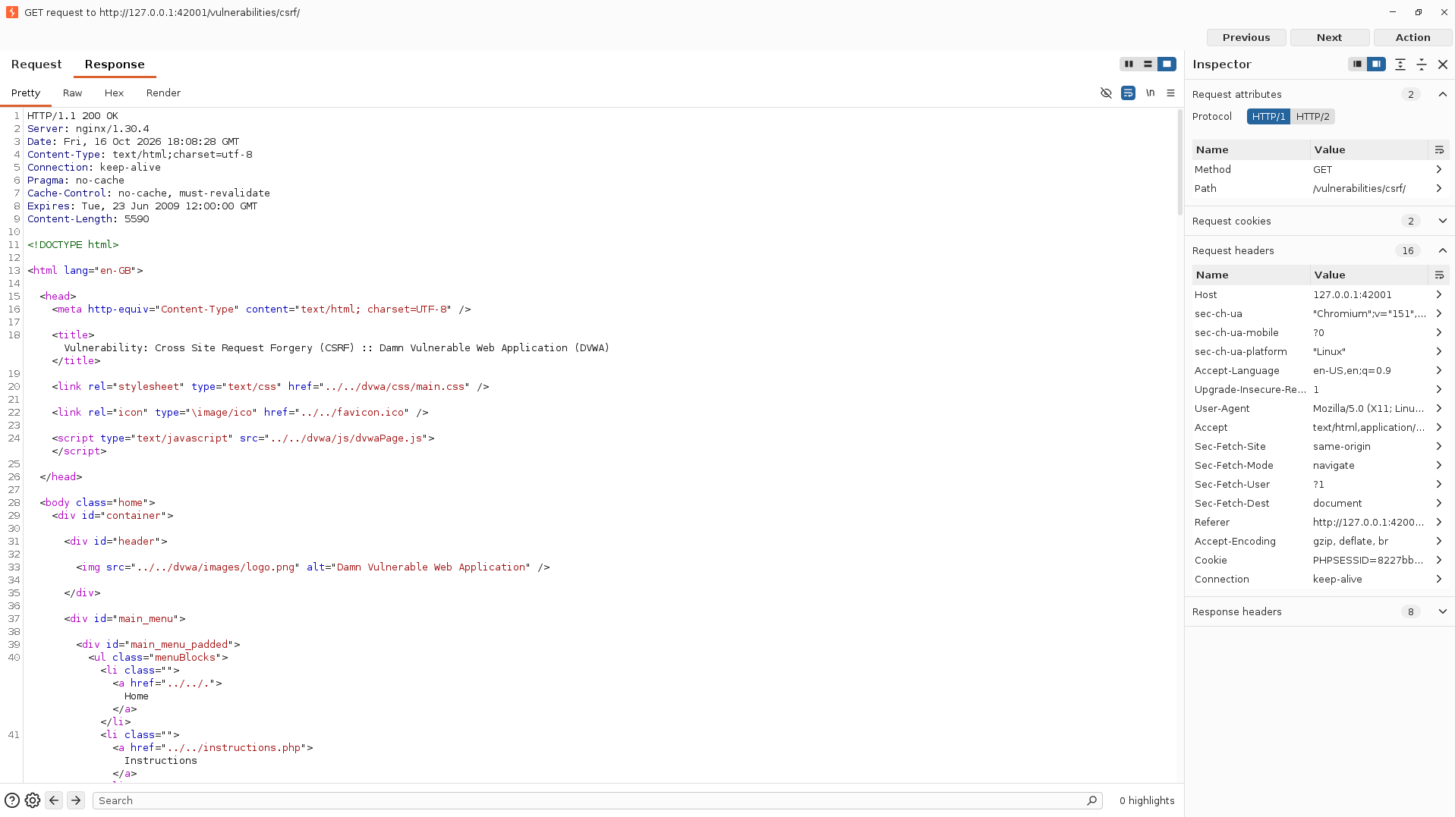
Figure 2: Burp Suite response showing the CSRF page returned with HTTP 200 OK.
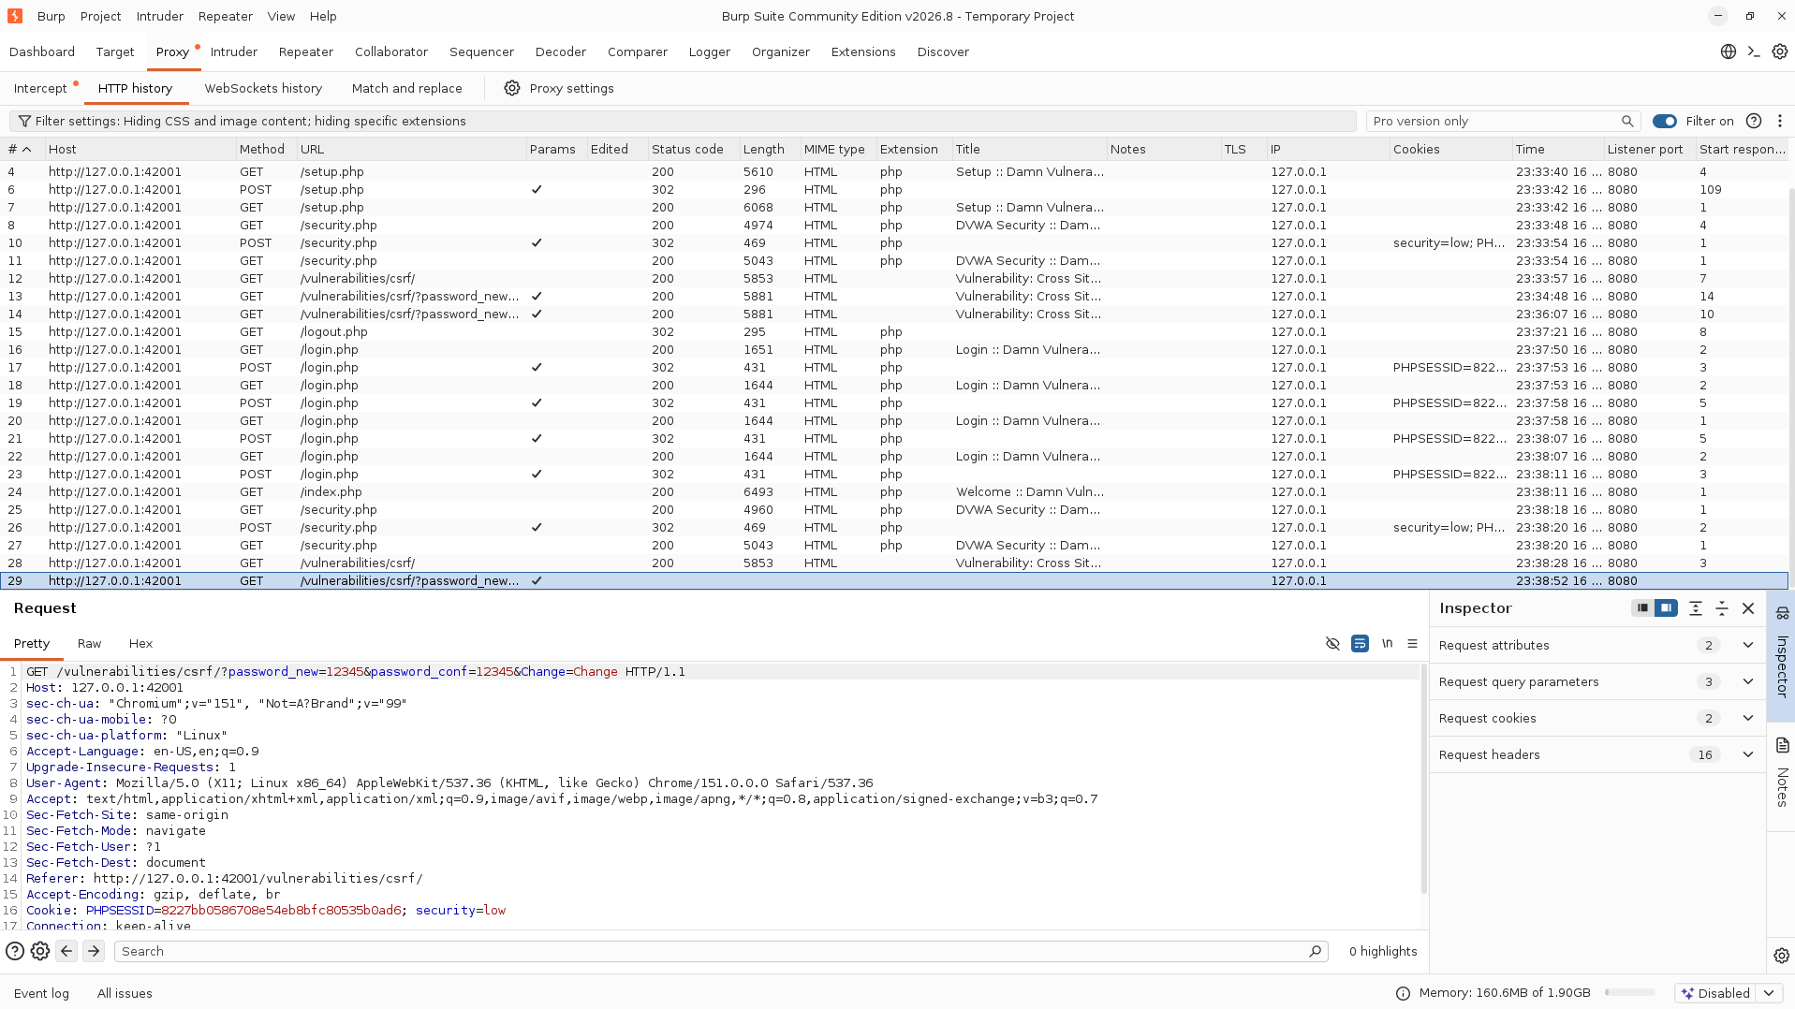
Figure 3: Burp Suite HTTP history and captured GET request containing password_new, password_conf, and Change parameters.

Result
The DVWA CSRF password-change form was accessed at Low security and its HTTP request was inspected using Burp Suite. The captured form and request show no user_token parameter. The provided evidence includes an HTTP 200 OK response; however, a successful password change was not conclusively demonstrated by the supplied screenshots. The final result should be marked successful only after verifying the change with DVWA's Test Credentials control.

Precautions
- Perform the exercise only in the local DVWA lab or another explicitly authorized test environment.
- Do not share session cookies, PHPSESSID values, or other authentication tokens in screenshots or reports.
- Use a temporary test password and restore the lab to its original state after the exercise.
- Do not interpret HTTP 200 OK alone as proof that a state-changing operation succeeded.

